1 Warrego St
Kensington
WA 6151

1 September 2014
Mr Dennis Eggington
Chief Executive Officer
Aboriginal Legal Service of WA
PO Box 8194
Perth Business Centre
WA 6849

Dear Dennis,
RE: Affidavit concerning the Late Stella Robinson
My name is Naydene Robinson, daughter of the late Stella Robinson (Sella/Cella) who was removed from Mulga Downs Station at the age of six in 1940 and taken to Moore River Settlement. At the settlement, my mother was given the name Stella Doris. Later, as a young girl at Carrolup mum had a son, my eldest brother Christopher Jackamarra, who was taken away from her when he was 18 months old and placed in Sister Kate's Children's Home.

Mum met my father, Reuben Robinson, the next year and had nine children to him. My father was another member of the stolen generations who had been taken to Moore River. My mum and dad lived together in Moora, which is where I was born. Then we moved to Cue, which is where I grew up with my five brothers and four sisters. I now live in Perth and I have six daughters, eleven grandchildren and two great grandchildren.

My mother's mother was Gertie (Gardi), a worker on Mulga Downs Station. Many years later my mother, Stella, was reunited with Gertie and her husband, Ginger Parker, both of the Banyjima language group, whose home country includes Mulga Downs Station. Gertie later told my mother, Stella, that mum's biological father was Lang Hancock. This was confirmed by several Banyjima elders. In addition, my mother's story was featured on page one of the Sunday Times (14 June 1992), the year Lang Hancock died.

At the time, I did not pursue the matter of our descent from Gina Rinehart's father, Lang Hancock, but in recent times I have been seeking assistance to prove the connection and whether it is possible to claim some rights as descendants. The anthropologist, Dr Bill Day, has built up a file on my mother's ancestry and history, but I believe that ALS may have some documentation that could assist our research.

In particular, I some years ago I was told that ALS was in possession of a signed affidavit (I am not sure who signed it) stating that the father of Stella Robinson is Lang Hancock. Therefore, Dennis, I write to you in the hope that you of your staff might be able to check the ALS records for any evidence of the aforementioned affidavit and/or any accompanying documentation on the ancestry of my mother Cella Doris @ Stella Robinson.

I would be very grateful if you could let me know if the above affidavit is available, and whether ALS could make it available to me. My mobile number is 0448 452 420 and my home address is as above.

Yours sincerely

Naydene Robinson
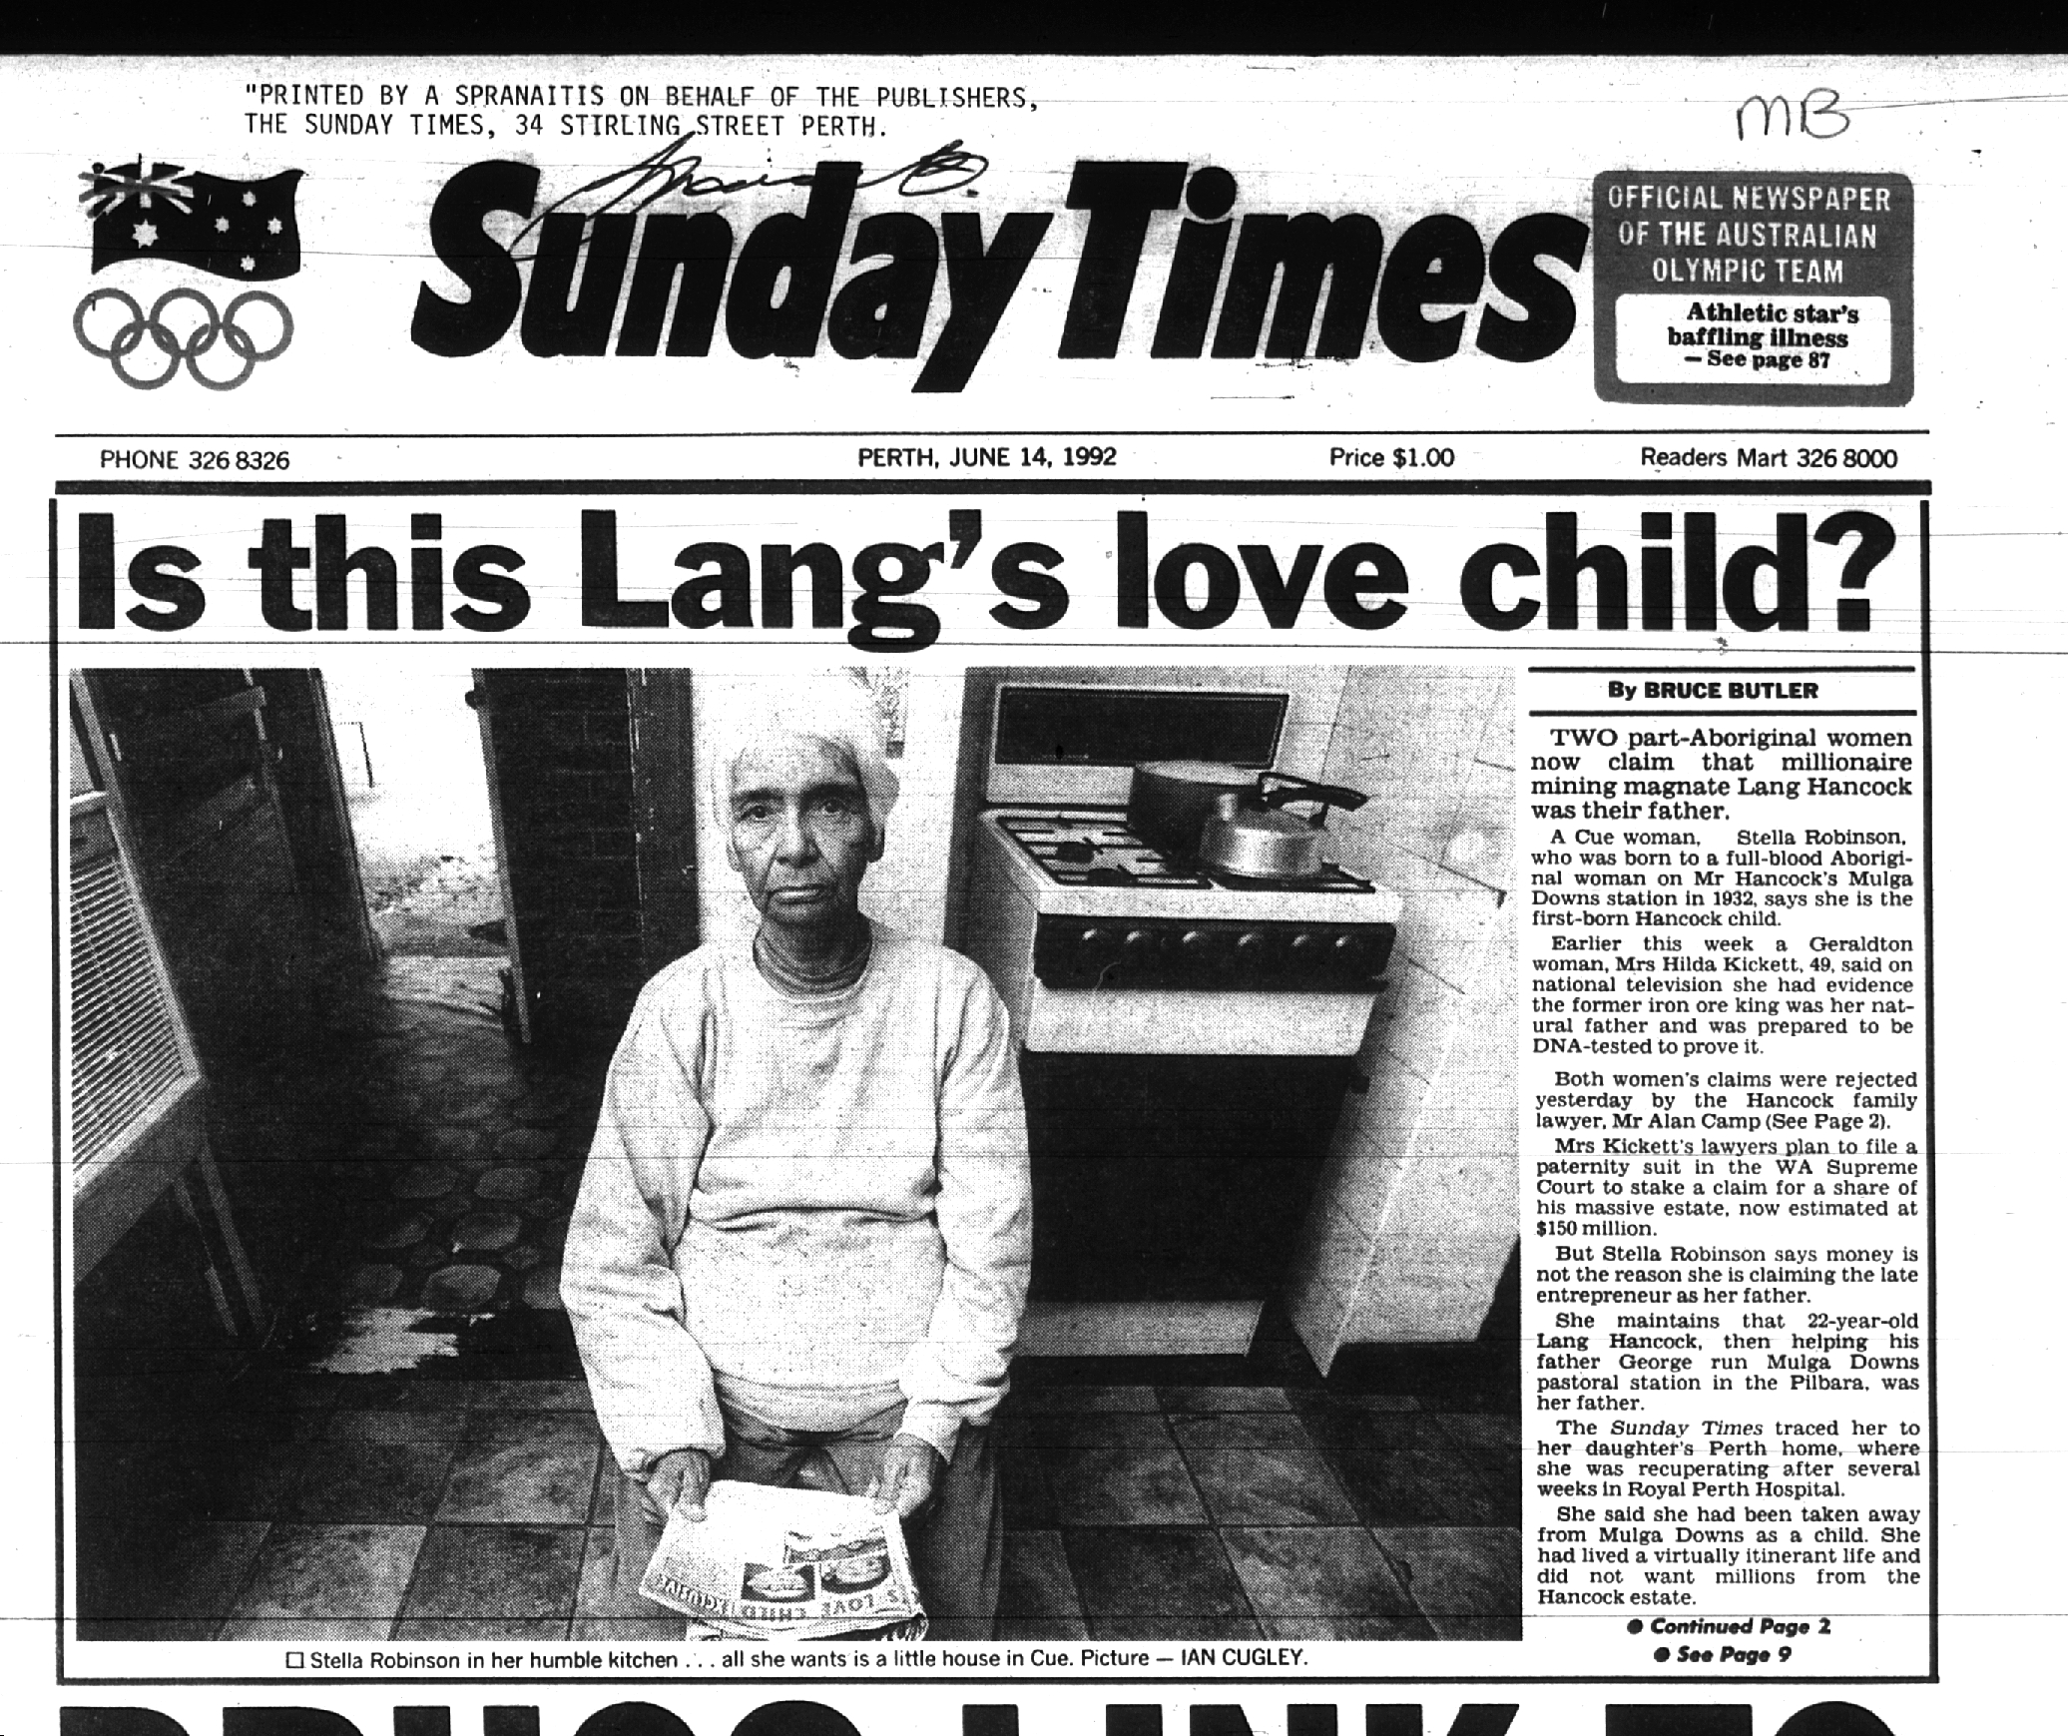
CC: Dr Bill Day, Consulting Anthropologist, PO Box 425, Maylands, WA 6931.

